Research Experience for Undergraduates
National Science Foundation

Friction Stir Welding and Post-Weld Heat Treating of
250-Grade Maraging Steel

Prepared by Brendan Kellogg

Advisors:
Drs. Bharat Jasthi and Michael West

Sponsor:
The National Science Foundation
Grant #1157074

Table of Contents
Abstract ………………………………………………………………………………………………………………………………………………….2
Introduction ……………………………………………………………………………………………………………………………………………2
Broader Impact ……………………………………………………………………………………………………………………………………….4
Procedure ……………………………………………………………………………………………………………………………………………….4
Results ……………………………………………………………………………………………………………………………………………………7
Discussion ……………………………………………………………………………………………………………………………………………….9
Conclusion …………………………………………………………………………………………………………………………………………….12
Future Work ………………………………………………………………………………………………………………………………………….12
Acknowledgements ………………………………………………………………………………………………………………………………13
References ……………………………………………………………………………………………………………………………………………14
Appendix ………………………………………………………………………………………………………………………………………………15

Abstract
Friction stir processing and post-weld heat treatments of 250 Grade Maraging Steel were performed using bead on plate friction stir welds with a Tungsten Rhenium Hafnium Carbide pin tool. Successful welds generally resulted from FSW parameters that produced higher amounts of heat, specifically a force of 6500 lbs., rotational speed of 200 rpm, and a longitudinal speed of 2 in/min. Post-weld heat treating indicates the possibility of over-aging with excessive temperature or time at elevated temperature illustrating the benefits of lower temperature aging for longer durations. Analysis of heat treated samples illustrates a uniform hardening effect of the treatment on and across the HAZ and weld nugget. The possibility of improved hardness over that of similarly heat treated parent material was also observed, indicating the potential for greater than 100% joint efficiencies and the benefits of friction stir processing the metal.

Introduction
Friction stir welding is a materials (usually metal) joining process in which melting of the material is not necessary. Instead a tool (see Figure 1) applies pressure with a specified amount of force onto the seam of the secured (clamped so they cannot move during welding) materials to be joined. The tool rotates at a specified rotational speed (rpm) and begins to “plunge” the pin into the material. Once the desired depth is reached (usually where the shoulder of the tool touches the material) the tool begins to travel along the seam, ideally maintaining constant pressure and rotational speed. In this way the tool combines its force and rotation, using friction to “stir” the material together (see Figure 2).
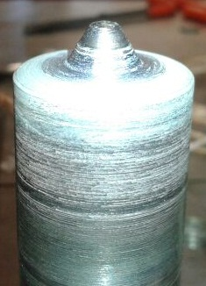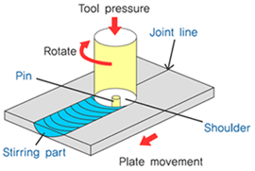
Figure 1 - TRHC FSW Pin Tool Figure 2 - Friction Stir Welding Process (“winxen.com,” 2007)
Little to no research has been documented on the application of friction stir welding (FSW) techniques to the specialized aerospace metal maraging steel. Maraging steels are a type of ultra-high strength iron alloy renowned for possessing superior strength and toughness without loss of malleability. These steels differ from regular steels mainly in alloy composition. For example, maraging steels contain very little to no Carbon (typically less than 0.05%) but instead contain high percentages of Nickel, Cobalt, and Molybdenum. These alloying elements are responsible for the high strength of the metal, a result of intermetallic compounds precipitated out of the iron based solution during a final heat treatment known as “aging.” In fact the name of the classification of metals is a portmanteau of “martensitic,” the principal microstructure of the steel, and “aging,” referring to the precipitation hardening process.
Upon cooling after casting, the high nickel content of maraging steels allows for the microstructure formed to be almost entirely body-centered tetragonal lath martensite, even without quenching. After cooling most maraging steels undergo at least one annealing heat treatment at temperatures over 800 C (duration dependent on thickness of sample) for the purpose of creating a uniform solution throughout the entire material. In this “solution annealed” condition, the metal is relatively soft and malleable. Therefore, it is in this condition the metal is most often machined, worked, and welded to the shape and specifications for its intended purpose. The final heat treatment instigates the precipitation hardening process, and is conducted at a much lower temperature than that of the annealing process, usually between 450 and 510 C and for 3 to 9 hours (Metals Handbook, 1990).
It is known that welding of this metal via more conventional welding techniques (arc, gas, etc.) often causes austenitic reversion of the martensite, and the best techniques documented to date involve the lowest possible heat input while still creating a successful weld (Shamantha, 2000). This presents the need for researching the possibility of friction stir welding this steel, since the process requires much lower heat levels.
The purpose of this research is to document the methods and success of friction stir welding this type of steel and record the material’s response to aging after welding. Three predominant welding parameters are considered: tool force, rotational speed, and longitudinal speed. Variations of these parameters are attempted followed by metallographic analysis, searching the welds for defects. For post-weld heat treatments, various temperatures and durations are administered to samples of successful welds, followed by an analysis of the mechanical properties of such samples. These results are compared to what is already known about the response to aging of not welded maraging steel and the mechanical properties achieved with other methods of joining.

Broader Impact
The success of friction stir welding maraging steel is unknown, so any resulting data on the topic, positive or otherwise, is beneficial. It is known that through more conventional welding techniques and subsequent aging processes, joint efficiencies achievable with this material can be upwards of 90% (Lampman and Crakovic, 1990). In general other methods of welding tend to be more cost effective than FSW and, for this material these other methods also tend to produce positive results. It is then necessary to know for industrial application whether or not there could be any feasible reason to implement friction stir welding or processing of maraging steel in manufacturing for any purpose.

Procedure
The following section outlines the methods by which each portion of the project was executed. All testing was conducted in accordance with the guidelines of the American Society of Testing Materials (specific tests listed in Table 1 below). Other methods, for example the post-weld heat treatments applied to the steel, is documented in text as clearly as possible.
Table 1 - ASTM Procedures (Mayer, 2010)
ASTM number | Description
E18-08b | Test Methods for Rockwell Hardness of Metallic Materials
E92-82 | Test Method for Vickers Hardness of Metallic Materials
E112-96 | Test Methods for Determining Average Grain Size
E3-01 | Guide for Preparation of Metallographic Specimens

Parent Material
The parent material, Maraging Steel – Grade 250 (AMS 6512), was shipped in the solution annealed condition (1700 F for 1 hour, air cool, 1500 F for 1 hour, air cool). For the purpose of observing how the mechanical properties of the metal altered with welding and aging, several tests were performed to assess the initial (as shipped) condition of the parent material.
- Hardness Test – This test uses an indenter to determine the general hardness of a sample. Results are reported on the “Rockwell C” scale.
- Micro-hardness Test – This test uses a diamond indenter to determine the hardness of a sample, and is more localized than the Rockwell test. Results are reported on the “Vickers” scale.
- Metallography – Samples were polished and etched for the purpose of determining microstructure and grain size of the solution annealed parent material.
The microstructure of the parent material was assessed to observe the changes that may occur in the weld nugget, heat affected zone, or even the parent material as a result of the aging (precipitation hardening) heat treatment. The procedure for metallography is outlined below.
- Samples were cut using a water jet cutter (dimensions 1” X ½” X thickness of plate).
- View orientations were selected with each sample to ensure equiaxed grain structure (surface, interior longitudinal, interior transverse). These cut samples were mounted in Bakelite for handling.
- The mounted samples were then polished using sanding discs and buffing pads.
- Lastly the samples were etched to reveal the microstructure of the metal.
Considerable time was spent determining which etchant revealed the microstructure of the steel most clearly. The composition of the chemical etchant that yielded the best results is listed below. The etchant was administered with a cotton swab, immersing the sample for up to several minutes until the microstructure became visible.
- 50 mL HCl
- 25 mL HNO₃
- 1 g CuCl₂
- 150 mL water
The hardness of the parent material was tested on two different scales in accordance with ASTM standard procedures. A 150 kg load was applied when measuring the Rockwell C hardness and a 500 g load was applied when measuring the Vickers micro-hardness with a dwell time of 20 seconds.

Parameter Optimization
Parameters of the friction stir welding process were tested for quality. The principal parameters considered were tool force exerted down on the metal plate, rotational speed of the tool, and traveling speed of the tool. Nine processing lines were drawn utilizing two different pin-length tools and a variation of the aforementioned parameters. After processing, the quality of the welds was tested by visual inspection, metallography, and hardness testing.
Several welds could be disregarded upon visual inspection – massive inclusions or voids were apparent without further testing. Most fine tuning of the parameters was completed with metallography, cutting the welds into cross sectional samples and polishing to reveal wormholes and other defects as well as the structure of the weld nugget, heat affected zone (HAZ), and parent material. The wormholes found were usually located near the bottom of the weld nugget on the advancing side, as depicted in Figure 3 below.
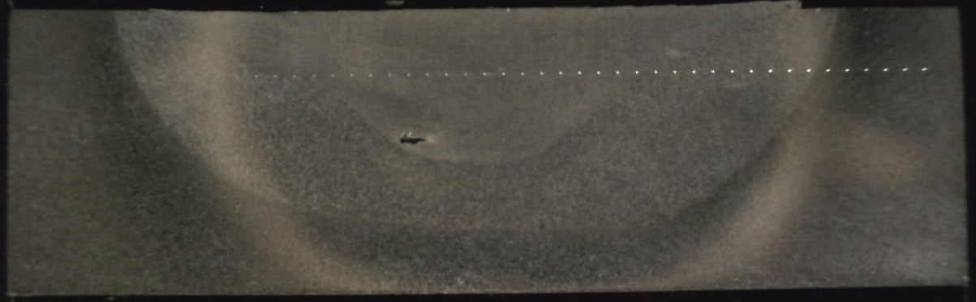
Figure 3 - Weld cross section showing nugget, HAZ, and wormhole defect
The manifestation of wormholes is likely related to the temperature reached during welding. The higher the temperature achieved during welding, the more viscous the material and therefore the more easily it will flow and “fill in” these voids. Conversely, the cooler the material the more it will stick to the pin as it rotates and leaves these voids behind. Also, the hotter the weld the slower the process and the greater the tool wear, both of which have negative impacts on the feasibility of industrial application. Optimization of welding parameters then proved to be a balance of all aforementioned considerations.
Lastly, micro-hardness testing was conducted on the metal in the as welded condition to observe the effect of friction stir processing on the mechanical properties of the metal. Care was taken in drawing indentations straight across the middle of the cross section of the weld so as to travel from the parent material, through the heat affected zone, across the nugget, through the HAZ on the opposite side, and back into the parent material. The path of micro-hardness testing indentations is visible in Figure 3 above.
Post Weld Heat Treatments
As previously mentioned, it is normal practice with maraging steel to weld and machine the metal in the solution annealed (as shipped) state due to its malleability and ductility in this condition. It is once machining and welding is complete when the aging (precipitation hardening) process is generally administered. It is known that a joint efficiency of 90%+ is achievable by other means of material joining then friction stir welding (Lampman and Crankovic, 1990). In order to determine the joint efficiency achievable with friction stir processing, a heat-treatment diagram was developed to optimize the mechanical properties after welding.
An outline of the times and temperatures at which samples were aged is shown below in Table 2. It is known that the high nickel content of the steel allows for a relatively slow cooling time without any austenitic reversion (Lampman and Crankovic, 1990). Also, precipitation hardening occurs at temperatures much lower than that of the melting temperature, or even austenitic reversion. Therefore it was not necessary for the heat treatments administered to follow any special heating or quenching rate. The samples were placed in the preheated furnace for the allotted amount of time, then removed from the furnace and air cooled under the breeze of a regular electric house fan. Lastly, to achieve consistent results all nine samples were cut from the same weld.
Table 2 - Post Weld Heat Treatments
Temperature Time (Fahrenheit) (hours) | 1 | 5 | 15
800 | Sample A | Sample B | Sample C
900 | Sample D | Sample E | Sample F
1000 | Sample G | Sample H | Sample I

All heat treated samples were subsequently polished, etched, and hardness tested in the same manner as previously mentioned samples and compared to the respective properties of the parent and as welded material.

Results
Parent Material
Metallography of the parent material revealed a lath martensitic microstructure with prior austenite grain size (martensite packet size) of between 6 and 7 ASTM. The microstructure of the parent material is visible in Figure 4 below. Figure 5 shows grain refinement in the nugget after welding.
Figure 4 - Lath Martensitic Microstructure of Parent Material Figure 5 – Post Weld Microstructure of Nugget
The hardness of the parent material, both micro and Rockwell C, was tested for the purpose of comparing to the welded and heat treated material. The results are outlined in Table 1 below.
Table 3 - Parent material hardness
Trial | Vickers Hardness (HV) | Rockwell Hardness (HRC)
1 | 317.3 | 29
2 | 302.1 | 29
3 | 306.5 | 29
4 | 314.4 | --
5 | 309.3 | --
Average | 309.92 | 29

Parameter Optimization
A map of welding parameters is shown below. The vertical axis of the map combines rotational speed and traveling speed into one parameter called “advance per revolution” (APR) referring to the longitudinal distance traveled by the tool across the metal with every revolution it makes. The horizontal axis indicates variations in force (the amount of pressure the tool pushes down on the metal with). Pictures of cross-sectional samples of the welds are included on the map to indicate which parameters produce voids and other defects and which yield the best quality welds. The parameters of each photograph are listed in the dark area just below each metal sample. As can be inferred from the map, the parameters yielding the best weld is located toward the right side in the center and is a result of parameters 6,500 lbs. and an APR of 0.01 in/rev.
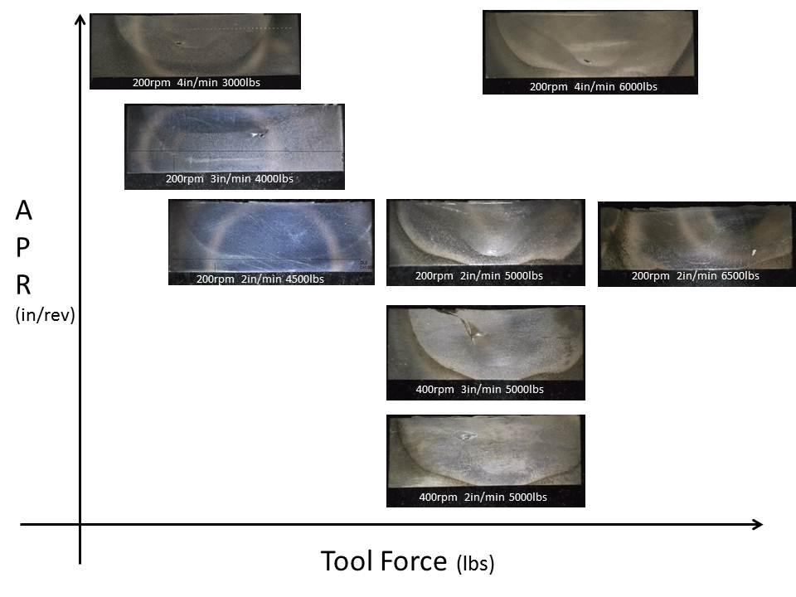
Figure 6 - FSW Parameter Mapping of Maraging Steel

Post Weld Heat Treatments
As described in the procedure, nine samples were heat treated – three different times for each of three different temperatures. The micro-hardness results of each can be found in the appendix at the end of this report. Since the micro-hardness across the weld and HAZ appear relatively even, an average hardness was calculated for each sample and used to generate the time-temperature diagram below. This diagram represents the effect of post-weld heat treatments on the weld and HAZ.

Figure 7 - Time-Temperature Post-Weld Heat Treatment Diagram
Discussion
In the solution annealed condition, maraging steel is relatively soft and malleable and therefore generally machinable and weldable (Madhusudhan and Ramana). It is then surprising to find the metal to be highly sensitive to the welding parameters, often leaving wormholes when the parameters were not precisely in tune. When observing the parameter map, it is observed that the weld of highest quality is to the right side in the center; however, the entire center line (top to bottom center) consists of three welds made with the same rotational and longitudinal speed (each with different amounts of tool force), all of which provide the highest quality welds on the entire map. In fact, the only visible defect among the three is found in the weld made with a 5,000 lb. applied tool force. Interestingly enough, this is the middle parameter of the three applied forces, the other two being 6,500 lbs. and 4,500 lbs. The weld made with the 4,500 lb. applied tool force was made with a shorter tool pin (150/1000 in), while the other two were made with a tool pin of length 230/1000 in. It seems likely, then, that the optimal parameters for friction stir welding this particular metal is a function of APR, tool force, and pin length (directly related to the desired thickness of the weld). It was noted that the best welds generally involved the most heat input (visually, the tool glowed the brightest), which is a result of all three parameters, but mostly a slow longitudinal traveling speed.
After welding, the outer heat affected zone suddenly becomes harder than the weld nugget and inner HAZ, and then gradually drops off in hardness as distance from the weld is increased as indicated in Figure 8 below (the borders between the inner and outer HAZ are located at 0.1” and 0.8”).

Figure 8 - Vickers Hardness across Weld in As-Welded Condition
The horizontal line in Figure 8 above represents the average micro-hardness of the parent material (measured before welding). When observing this graph it is interesting to note the average hardness of the weld nugget (0.275” – 0.6”) and the inner HAZ (0.1” – 0.275” & 0.6” – 0.8”) combined is likely very near to this line, while the outer HAZ (either extreme side of the graph) is much harder than the parent material. It can also be noted that the inner HAZ tends to be a little softer than the nugget, while the nugget tends to be a little harder than the parent material. Speculating on these results implicates the possibility of the following occurring during welding:
- The grain size is refined in the nugget during the welding process making for a harder material. The post weld microstructure of the nugget can be seen in Figure 5, while the pre-weld microstructure of the parent material can be seen in Figure 4, both on page 7.
- Due to the intense heat of the welding process, some annealing (austenitic reversion) may be occurring in the innermost region of the HAZ, resulting in a slight softening of the material.
- The outer area of the HAZ is subject to a lesser degree of heat. This may be causing some precipitation hardening resulting in the sudden and drastic difference in micro-hardness since it is known that the incubation time for precipitation to occur in these steels is almost nothing (Lampman and Crankovic, 1990). The visible line between the inner HAZ and the outer HAZ then likely represents the temperature at which the material does not anneal, but instead ages.
Again, these three inclinations are merely speculation and would require further testing to verify.
After heat treating (precipitation hardening), the hardness results tend to become more uniform as seen in Figure 9 below. Graphs of all micro-hardness across weld of heat treated samples can be found in the appendix, but all results appear to indicate a hardness homogenizing effect of the aging process.

Figure 9 - Micro-hardness After Heat Treating
Discrepancies in these trends might be found with further experimentation. For example, in the interest of frugality, as many welds as possible were processed on a single plate of the metal while developing the process parameter map. Consequently, one of these welds was cut up and used to develop the heat treatment diagram. The possibility exists for a continuous heat affected zone between welds due to their proximity to one another, which may skew the micro-hardness results. Further research is required to verify this hardness homogenizing effect.
The post-weld heat treatment diagram (Figure 7) indicates a temperature of about 900 F is an ideal heat treating temperature. However, the graph seen in Figure 10 below, although indicating different hardness values than that of the post-weld heat treatment diagram (indicating heat treatments of unprocessed material), does also indicate that at a certain number of hours the metal treated at 800 F will surpass the hardness of the metal treated 900 F. Furthermore, with even more time the metal treated at 700 F surpasses the hardness of the metal treated at 800 F.
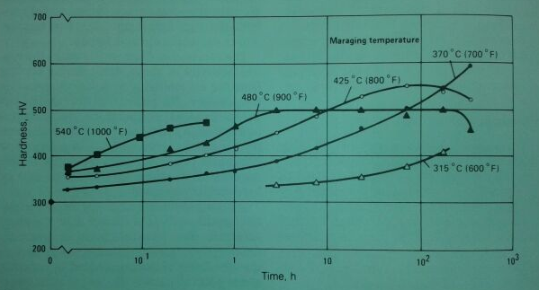
Figure 10 - Precipitation Hardening of 250 Grade Maraging Steel (Lampman and Crakovic, 1990)
This indicates the possibility of changes in the post-weld heat treatment diagram with further data acquisition, treating samples at different temperatures and for longer durations. It was mentioned previously in this paragraph that the hardness values between Figure 7 and Figure 10 do not agree. This may be due to the processing history of the metal or other variations, but is likely due largely in part to the fact that the results of Figure 7 are concerned only with the welds, and the results of Figure 10 deal strictly with the parent material. The differences between these two graphs beg for more information on the aging of the metal during the welding process. It can also be noticed that the samples heat treated after welding tend to be harder than the parent material under the same heat treatment. This leaves the door open to further research on the possibility of achieving greater mechanical properties of this metal with friction stir processing and subsequent heat treating.

Conclusions
Optimal parameters for friction stir welding maraging steel depend on the pin length of the tool, but will likely require a large heat input to avoid the presence of wormholes; in this case (0.25” thick sheet metal, 0.230” pin) parameters of a rotational speed of 200 rpm, a longitudinal speed of 2 in/min, and an applied tool force of 6,500 lbs. yielded the best results. Lower temperatures and longer durations at these temperatures result in the best hardness response to post-weld heat treatments. The highest hardness achieved via post-weld heat treating in this research was accomplished by treating at 900 F for 15 hours. Post-weld heat treating of the metal results in micro-hardness uniformity across the weld nugget and HAZ.

Future Work
Further refinement of the optimal welding parameters can be achieved exploring different tool force options at or around the parameters of a rotational speed of 200 rpm and a longitudinal speed of 2 in/min; the optimal force parameter likely lies somewhere between 5,000 lbs. and 6,500 lbs. The lowest heat input possible while still achieving a weld free of wormholes with complete closure will yield the best results.
Further data should be acquired on post-weld heat treatments because the shape of the diagram would likely change. For the temperatures that have been tested, longer treating times are required so the point of over aging can be known for each temperature. It is clear from the current diagram that 1000 F is likely too high an aging temperature, so it is not necessary to test any higher temperature than that. However, Figure 10 indicates a treating temperature of 700 F can yield very positive results if aged for the appropriate amount of time; it also indicates the a temperature of 600 F is probably too low to accomplish any aging in any reasonable amount of time. Therefore the 700 F temperature is likely the lowest treating temperature necessary to explore.
It is also necessary to heat treat samples of the parent material at similar temperatures to verify the results of Figure 10 and compare to Figure 7 (due mainly to the unknown processing history of the metal tested behind Figure 10). This information could be useful in determining if and to what extent the metal is aged during the welding process. The possibility of aging during welding should also be explored using microscopy, looking for precipitates in the outer area of the HAZ.
Since metal treated post-welding appears to be harder than similarly treated parent material, the possibility of beneficial friction stir processing should also be explored. If it can be known that the metal does age during the welding process, and that the hardness also becomes uniform with heat treating, then it may be possible to achieve greater hardness throughout the entire material with the correct friction stir process and subsequent heat treatment compared to untreated maraging steel. It may also be possible to achieve joint efficiencies greater than 100%.
More testing of mechanical properties of the material should be conducted both as welded and post-weld heat treated, particularly tensile testing and grain size assessment. Acquiring this data would provide information on a broader variety of mechanical properties for a more complete assessment on the effect of friction stir welding and subsequent heat treatment on maraging steel.
Lastly, for the purpose of industrial application, an analysis of tool wear during the friction stir welding of maraging steels could be conducted. Upon visual inspection, no noticeable tool wear was observed, which is slightly surprising due to the strength of the material and the high amounts of heat involved with the welding process. Important factors to research with a tool wear analysis would be the required frequency of remachining of the tool, lifetime of the tool used strictly on maraging steel (number of times the tool can be remachined), and an estimation of cost per length of weld (due to the high cost of the tungsten rhenium hafnium carbide tools).

Acknowledgments
A special thanks is extended to the National Science Foundation for providing grant #1157074 and making this research possible. Dr. Michael West is also appreciated for making this program possible at the South Dakota School of Mines and Technology, creating more responsibility for himself during what must have already been a very busy summer. Gratitude is expressed for the guidance of Dr. Al Boysen who kept all the REU students on track. Without the resources and staff of the AMP Center, particularly Todd, Tim, Chris, and Matt, this project would not have been possible. Appreciation is expressed for the love and support provided to this researcher by his wife, Julia Funke. And lastly but mostly, appreciation is expressed to Dr. Bharat Jasthi who spent more time and energy than was truly his responsibility to become personally invested in the research and outcome of this project – thank you.
Bibliography

- Mayer, V. A. (2010). Annual book of astm standards . (Vol. 3.01). Baltimore, MD: ASTM International.
- Reddy, G. M., & Ramana, P. V. (2011). Role of nickel as an interlayer in dissimilar metal friction welding of maraging steel to low alloy steel. Journal of Materials Processing Technology, (212), 66-77.
- Shamantha, C. R., Narayanan, R., Iyer, K. J. L., Radhakrishnan, V. M., Seshadri, S. K., Sundararajan, S., & Sundaresan, S. (2000). Microstructural changes during welding and subsequent heat treatment of 18ni (250-grade) maraging steel. Materials Science and Engineering, A(287), 43-51.
- Viswanathan, U. K., Dey, G. K., & Asundi, M. K. (1993). Precipitation hardening in 350 grade maraging steel. Metallurgical Transactions A, 24A(November), 2429-2442.
- Callister , W. D. (2007). Materials science and engineering:an introduction. (8 ed., pp. 359-411).
- Maraging steels. In (1990). H. Lampman & G. Crankovic (Eds.), Metals Handbook Volume 1: Properties and Selection: Irons, Steels, and High Performance Alloys (pp. 793-800). Materials Park, OH: ASM International.
- winxen.com. (2007). Retrieved from http://eng.winxen.com/generic/home-frame-1.aspx?tplcode=BODYmn2007723142021

Appendix I – Micro-hardness data

Post-Weld Heat Treatment Outline
Temperature Time (Fahrenheit) (hours) | 1 | 5 | 15
800 | Sample A | Sample B | Sample C
900 | Sample D | Sample E | Sample F
1000 | Sample G | Sample H | Sample I

800 Fahrenheit

900 Fahrenheit

1000 Fahrenheit

Combined Micro-hardness Data
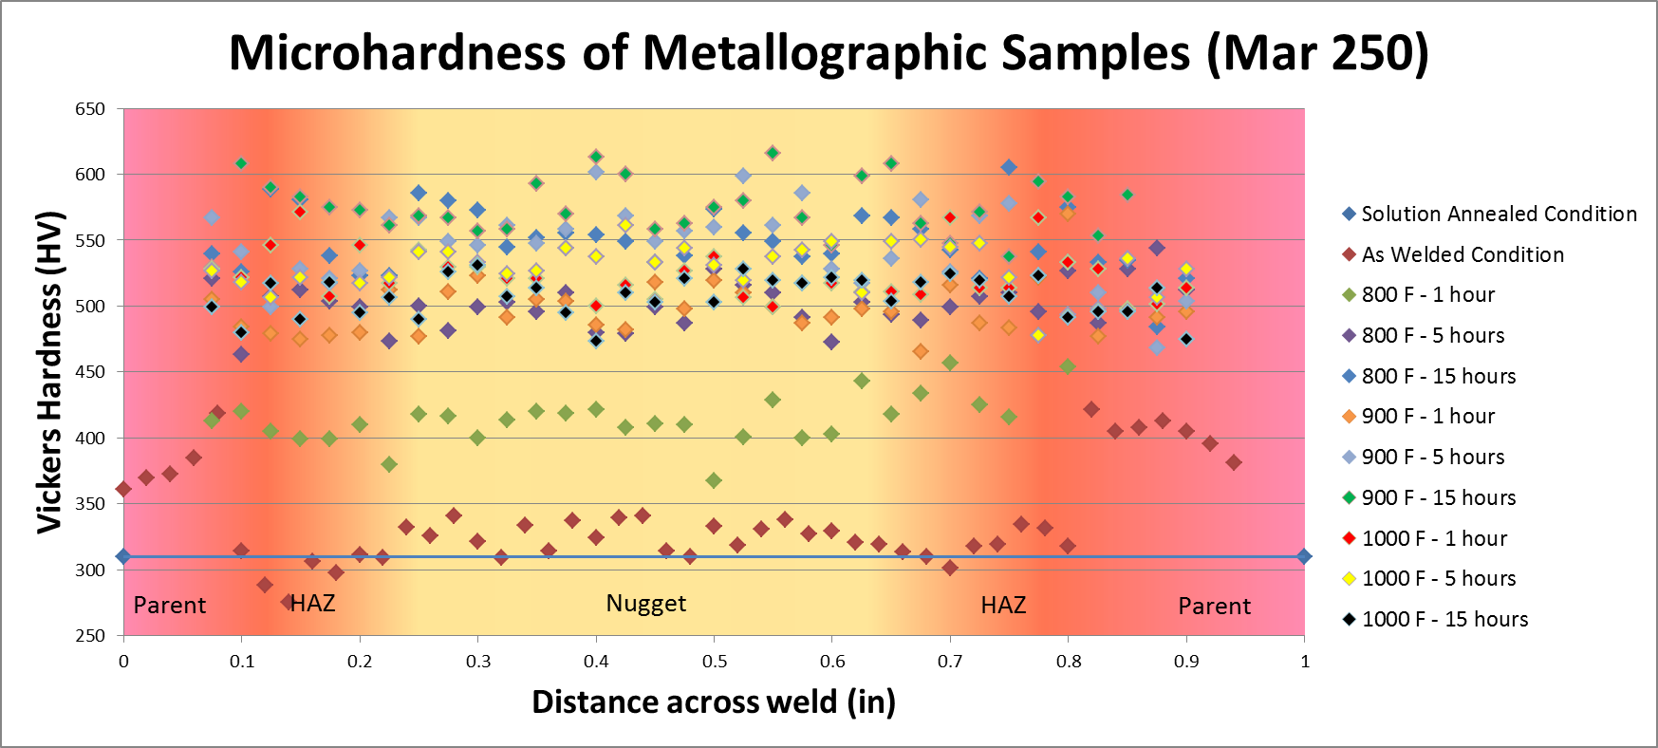

This is the material specification designation as indicated by the shipping documents. AMS – Aeronautical Materials Specification
Thickness of the metal plate varied slightly, and was generally equal to 0.25”+/-0.125”.
Duration of time the samples were immersed in the etchant tended to vary, particularly so once the etchant was applied to the welded and heat treated samples.
Unfortunately, a comparative heat treatment was not performed on the parent material used in this research project. This statement relies on the information provided by the borrowed graph. For the purpose of verification, a similar heat treatment should be performed on the parent material.

